Arthritic Alberta jaguar treated with cutting-edge human procedure 'It's not everyday that we have a patient who could wake up and pounce and kill you'
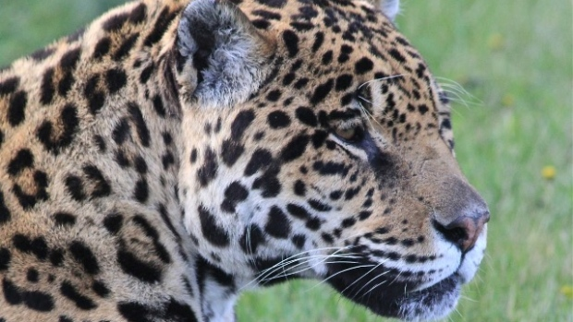
CBC News Posted: Apr 24, 2017 11:05 AM MT Last Updated: Apr 24, 2017 11:05 AM MT A jaguar is recovering from an unique arthritis procedure after a podiatric surgeon saw the big cat in an
Alberta zoo.
Mia — a 14-year-old male at the Discovery Wildlife Park near Innisfail — is likely the first jaguar to have the procedure, which is usually reserved for humans.
Animals in the emergency room Calgary Zoo aims to boost animal welfare, ethics with new committee
Dr. Karim Ravji, who runs a private orthobiologics clinic in Edmonton, noticed the jaguar's poor health during a visit to the zoo last summer.
"The groundhogs would actually come and taunt it and steal its food and stuff. This beautiful, majestic animal could not leap or pounce ...and actually was lying there in pain," he told The Calgary Eyeopener.
Ravji talked to zoo owner Doug Bos about Mia, who has arthritis in his two front knees.
"We were relieving the pain from that with medication, but the medication is just really hard on the animal. It shortens their life span up dramatically. It affects the kidneys and the liver and all that sort of stuff," said Bos.
Jaguar sedated
Ravji consulted with animal experts and found two veterinarians who could help with drawing plasma, spinning off the platelets, and then re-injecting them into Mia's front knees in hopes of reducing inflammation and promoting tissue regeneration.
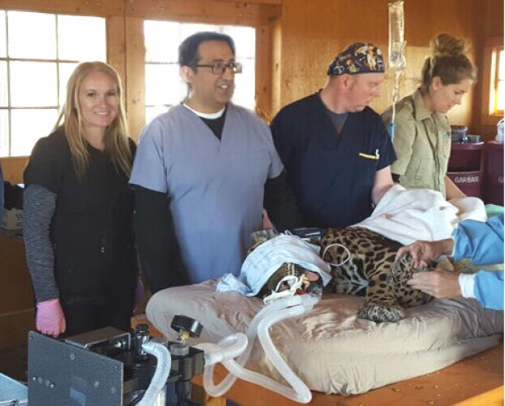
"We supplied them with equipment," he said.
Mia was sedated with a blow dart and then given general anesthesia.
"It's not everyday that we have a patient who could wake up and pounce and kill you," said Ravji.
The jaguar was walking again right after the procedure and seems to be doing better, but it takes eight to 12 weeks to see an improvement, Ravji said.

"It's kind of exciting because if it is really effective then it's kind of breaking ground for other zoos and other animals," added Bos.
Zoo staff, the vets and Ravji's medical group all donated their time, and may try and help other animals at the zoo.
"We would do it again," he said. "There's some grizzly bears that have arthritis and Mia's twin, another jaguar, that's got some tendinitis and arthritis issues. This type of injection can be used for tendon, ligament or joint. You just have to have the proper equipment and a good cell collection

